130089872

Pusdo Code & flow Chart

Contents

Table of Figures 2

Introduction 3

Admin Login 3

Pseudocode 3

Admin Menu 6

Pseudocode 6

Pond calculator measurements 9

Pseudocode 9

# Table of Figures

Figure 1 Admin Login 4

Figure 2 Login UI 5

Figure 3 Admin Menu 7

Figure 4 Admin menu default UI 8

Figure 5 New user section 8

Figure 6 Length validation flow chart 10

Figure 7 Pond Calc UI 11

## Introduction

Inside this document is the pseudo code and flow charts of the pond calculator with descriptions of the UI and explaining how it functions.

## Admin Login

As shown below (fig1) this pseudo code is so the program can determine that a log in is either successful or unsuccessful. Upon being successful, the current page would close and display the ‘Admin Page’. When unsuccessful a text box would appear saying that the login is invalid.

### Pseudocode

if user is adminuser and password is adminpassword

show the login form

hide previous form

else

Show a message box “invalid username and password”

Clear text input for username and password

Move key input back to username box

Figure 1 Admin Login

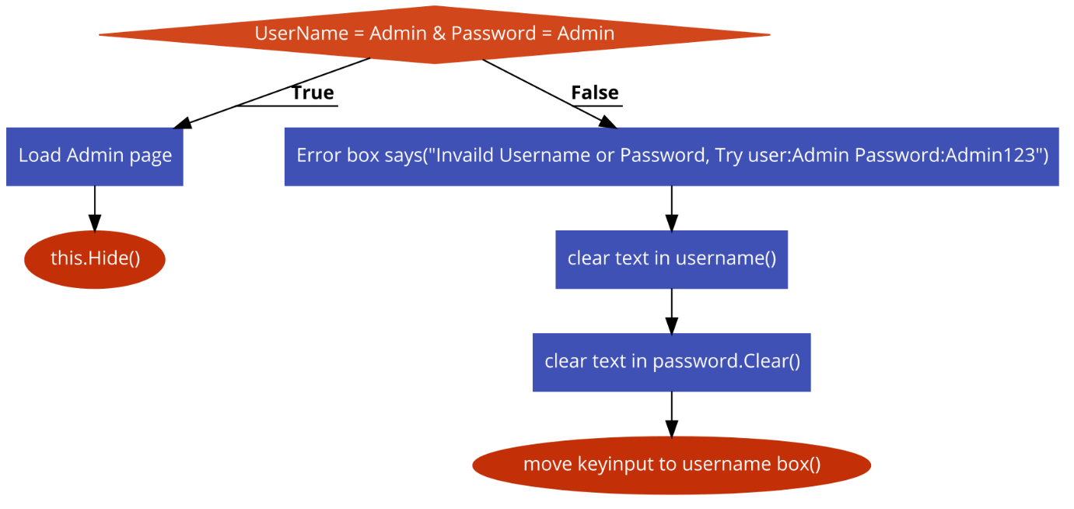

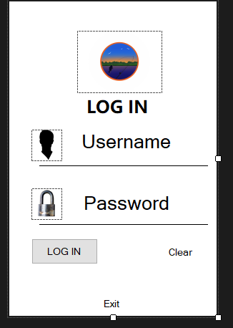

Figure Login UI

User inputs the admin username here

User inputs the admin password here

Clicking this clears the text on the username and password section

Clicking this button checks for the required information

Clicking this exits the application

## Admin Menu

This flowchart (fig3) may look confusing at first glance, but once explained in this description it is extremely easy to understand. The purpose of this code is to prevent the user from being confused and overwhelmed with unneeded information as default the application is displayed as (fig4) where it is limited what can be altered. This provides the user with a list of options upon selecting an option and entering the correct password. The information related to that option will become active (fig5) allowing the user to input or continue to the next form once the progress bar is filled.

### Pseudocode

If NewUser is checked and correct password

Show NewUser section and return other sections to their default UI

If RemoveUser is checked and correct password

Show RemoveUser section and return other sections to their default UI

If None is checked and correct password

Show Continue button and return all sections to their default UI

Figure 3 Admin Menu

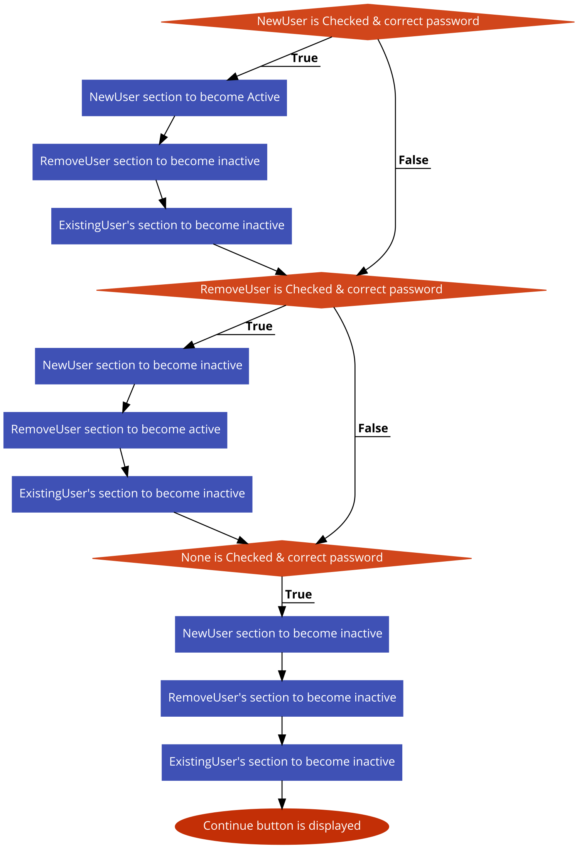

Figure 4 Admin menu default UI

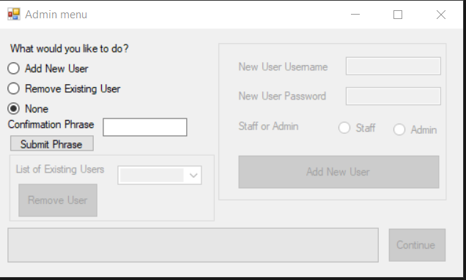

Add New User section displaying information

Required password for input to function

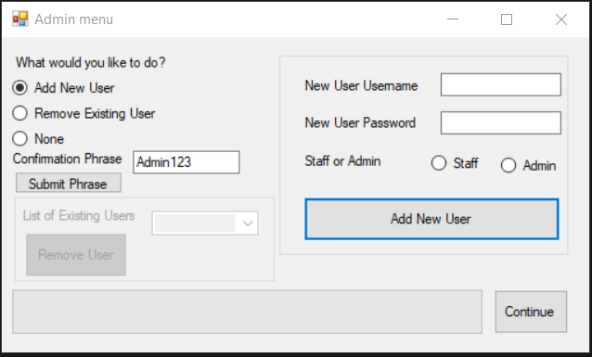

Figure New user section

Select an option to display information

Progress bar this must be full before application allows user to progress.

bar begins to move once the user clicks continue.

Remove User section displayed as currently inactive

Once progress bar is full clicking this button loads Pond Quote

Confirm selection

## Pond calculator measurements

When inputting the length of the pond it must be between one and ten meters. This flow chart (fig 6) demonstrates the validation of the length input (fig 7). This is also used for the width and depth when the requirements of the application progresses. But if the requirements are not met a message box will appear explaining the fault.

### Pseudocode

If pond length box is blank

Show a message box “please enter desired length”

If pond length box is less than 1

Show a message box “length cannot be less than 1 meter”

If pond length is more than 10

Show a message box “length cannot be greater than 10”

If pond length is between 1 and 10

Check width of pond

And repeat the above statements

Check depth of pond

And repeat the above statements

Figure 6 Length validation flow chart

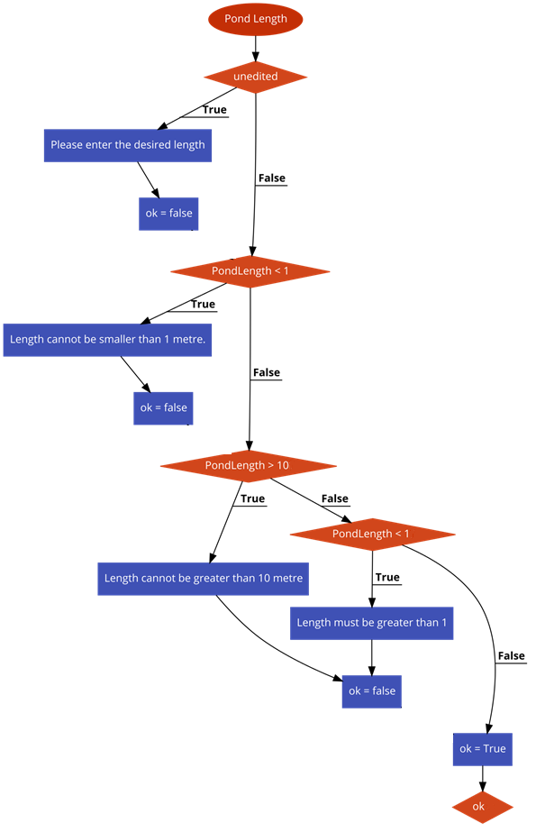

Clear’s and resets all existing information

Drop down box of different pond edges

User inputs measurements

Close application

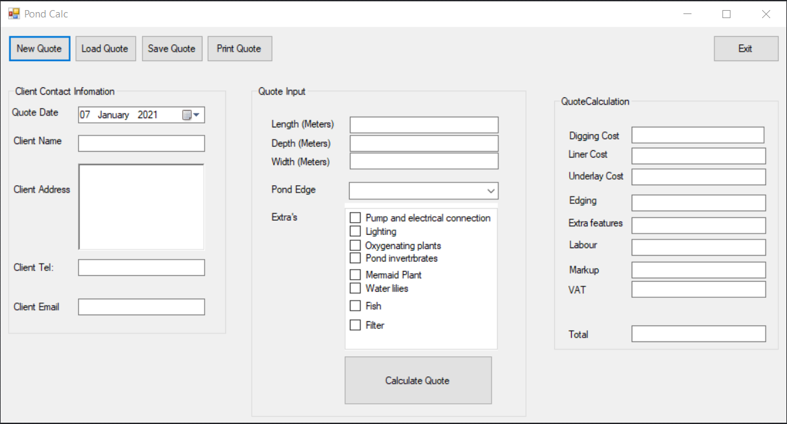

Figure Pond Calc UI

If all validation is approved display costs in quote calculation

All clients contact information to be inputted here

A tick box that adds the cost of features to the quote

Box to display all quote related information